**Project Design Phase**

**Solution Architecture**

|  |  |
| --- | --- |
| Date | 15 February 2025 |
| Team ID | LTVIP2026TMIDS81651 |
| Project Name | Explore with AI: Custom Itineraries for Your Next Journey |
| Maximum Marks | 4 Marks |

**Solution Architecture:**

Solution architecture for *TravelGuideAI* defines how the system converts user travel needs into intelligent, AI-generated itineraries. It connects user requirements, application logic, and generative AI services into a smooth, scalable system.

Goals of the TravelGuideAI Solution Architecture

● Deliver an AI-powered travel planning solution that generates personalized itineraries based on destination, days, and nights.

● Clearly define system structure and components (UI, backend, AI model, and APIs) so stakeholders understand how the system works.

● Outline features and development phases such as itinerary generation, user input handling, and result presentation.

● Specify technical requirements for deployment, API integration, and data handling.

● Ensure scalability and reliability so multiple users can generate itineraries simultaneously.

● Provide a blueprint for development and maintenance, enabling future upgrades like hotel suggestions, maps, and budget planning.

**Solution Architecture Diagram:**

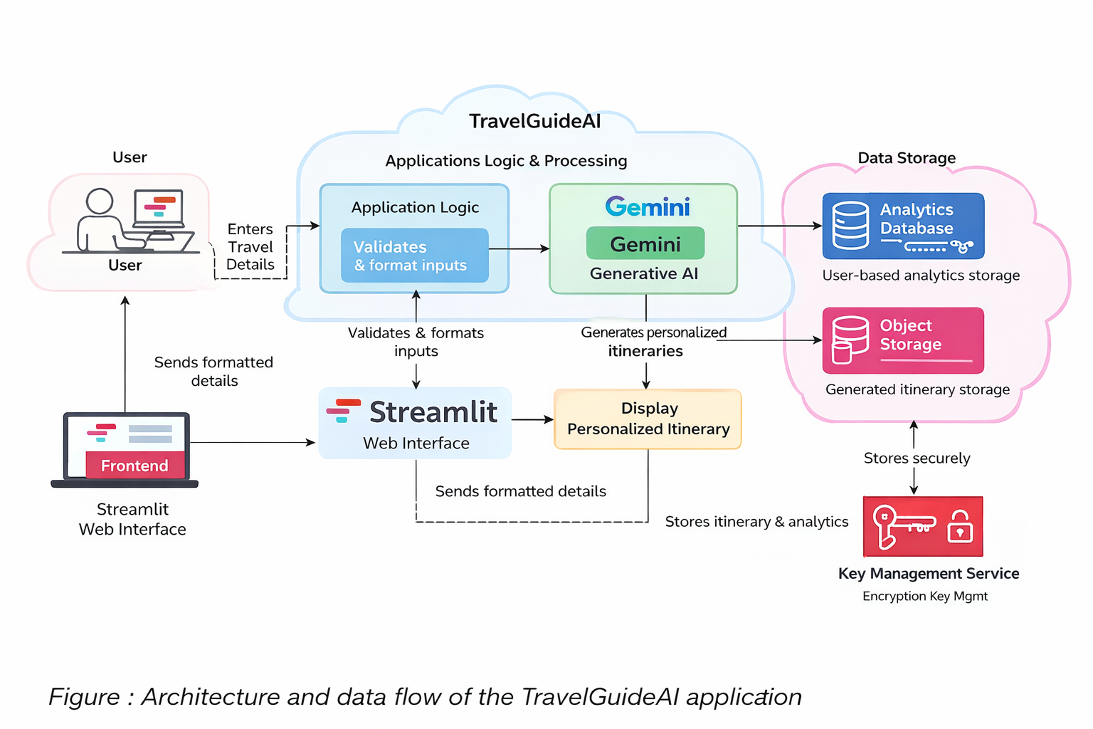

**Reference:** [**https://aws.amazon.com/blogs/industries/voice-applications-in-clinical-research-powered-by-ai-on-aws-part-1-architecture-and-design-considerations/**](https://aws.amazon.com/blogs/industries/voice-applications-in-clinical-research-powered-by-ai-on-aws-part-1-architecture-and-design-considerations/)